CURRICULUM VITA
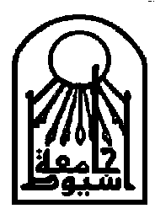
Assiut University
Faculty of Veterinary Medicine
Department of Forensic Medicine and Toxicology
Name: Zakaria Mokhtare Zaky  Current Position: Vice dean for student's affairs, Professor of Forensic Medicine and Toxicology  Contact Information:  Address: Work; Department of Forensic Medicine and Toxicology, Faculty of Vet. Medicine, Assiut University Assiut, Egypt.  - Address: Private; 25 Mohammed Tawfek Kashaba street, Assiut, Egypt.  - E-mail:zak57zakizakaria@yahoo.com  - Phone: Work; 0020882411636  0020889201252  - Private; 0020882337332  - Mobile:00201118430545  - Fax: 0882342211 | 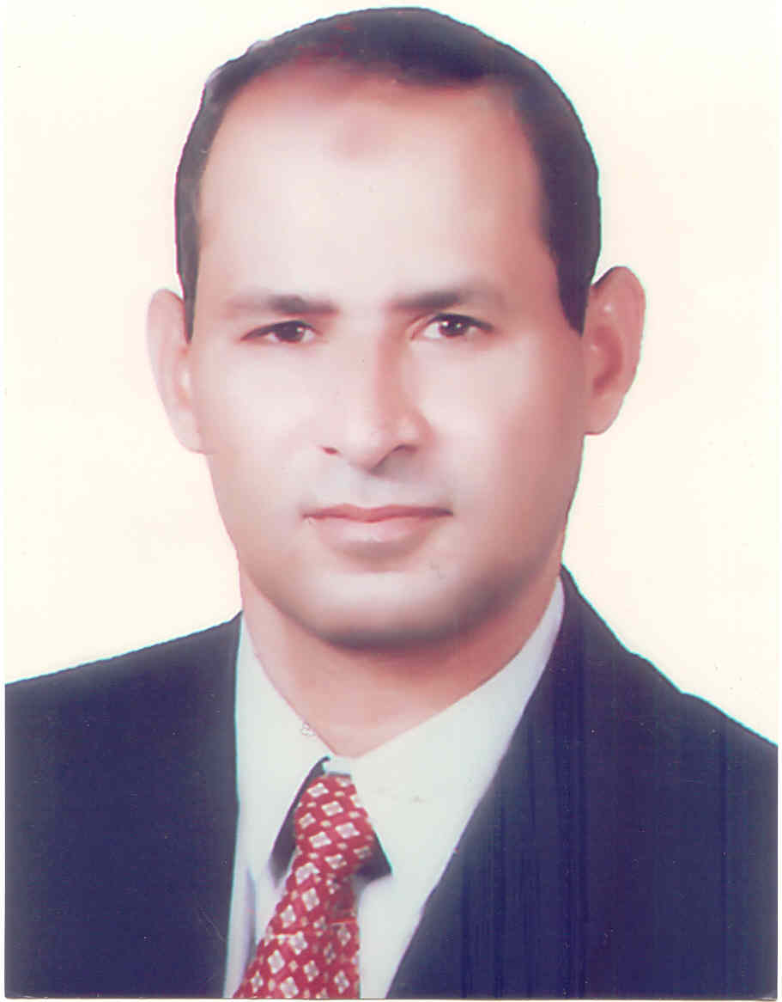

Education:

Degree | Year | Discipline | Institute
B. V. Sc. | 1980 | Vet Science | Department of Forensic Medicine and Toxicology, Faculty of Vet. Medicine, Assiut University Assiut, Egypt.
M. V. Sc. | 1986 | Forensic Med. & Tox. (Mycotoxins Residues)
Ph D. V. Sc | 1993 | Toxicology (Mycotoxins Residues)

Personal:
Name: Zakaria M. Zaky
Date & Place of Birth: 24/11/1957, Assiut.
Nationality: Egyptian.
Marital Status: Married.
Address in Egypt: Department of Forensic Medicine and Toxicology, Faculty of Vet. Medicine, Assiut University Assiut, Egypt.
Stages of Education:-
1963-1969 El-Tahrear Primary School, Assiut.
1969-1972 El-Kairea Preparatory School, Assiut.
1972-1975 Nasser Secondary School, Assiut.
1975-1980 Faculty of Veterinary Medicine, Assiut Univ., Assiut, Egypt.
-June, 1982- Feb., 1986: Demonstrator for Forensic Medicine & Toxicology, Dept. of Forensic Medicine & Tox., Fac. of Vet. Medicine, Assiut University.
-March, 86- June, 91: Assistant Lecturer in the same department.
-June, 1991- November, 1992 in Chemisches Untersuchungsamt, Treir, Germany for training in chemical analysis of foodstuff
-November, 1992- January 1993: Finishing of Ph. D. in the home country.
-Feb. 1993-1998: Lecturer of Forensic Medicine & Toxicology, Dept. of Forensic Medicine & Tox., Fac. of Vet. Medicine, Assiut University.
-March 1998-2003: Assistance professor for Forensic Medicine & Toxicology, Dept. of Forensic Medicine & Tox., Fac. of Vet. Medicine, Assiut University.
-Specialist in hormonal and drug residues in Ministry of Agriculture, Kingdom of Saudi Arabia from 17/5/2001 to 14/8/2008.
-3/August 2003 to date: Professor for Forensic Medicine & Toxicology, Dept. of Forensic Medicine & Tox., Fac. of Vet. Medicine, Assiut University.
-Manager of the Central Laboratory in the Fac. of Vet. Medicine, Assiut University from 25-6- 2009- to date.
- Vice dean for student's affairs: from 1/8/2012- to 7/2015
Educational Qualifications & Training's:-
1- Bachelor of Vet. Med. Sci.: May, 1980 (Good), Faculty of Vet. Medicine, Assiut University, Egypt.
2- Master of Vet Med. Sci.: Feb. (1986) in Veterinary Toxicology under the title of (Aflatoxins Residues in Rations, Eggs and Tissues Obtained from Chickens Laying Flocks in Assiut Province), Faculty of Vet. Medicine, Assiut University.
3- Ph. D. of veterinary medical science: February (1993), in vet. toxicology under the title of (Studies of aflatoxin residues in dairy and feedlot cattle at Assiut Governorate), Faculty of vet. medicine, Assiut university.
4- Training courses in “Mycotoxins residues analysis” in the International Research Center and central laboratory of Mycotoxins, Dokki, Cairo.
5- Training and study in Chemisches Untersuchongsamt, Treir, Germany on different methods of toxicological analysis of foodstuffs.
6- Microcomputer Software training courses, (DOS and Introd. to SAS) from 8/1/1995-6/4/1995.
7- 4th ALEXANDER HOLLANDER TRAINING COURSE IN GENETIC TOXICOLOGY, “Practical training in contemporary Genetic Toxicology” at the Cairo Meridian Hotel, 15-18 September 1997, Cairo, Egypt.
8-Modern Techniques in Molecular Biology and Their Practical Applications Training Course. March 11-15/2001. The Molecular Biology Research Center, Assiut University
8- Water training course for successfully attending and completing an instruction and practical program covering LC/MS Operation Training Course. March 5-9 /2005. Gulf Scientific Corporation.

Present Position:
Professor of Forensic Medicine and Toxicology for under- and post-graduate students and Clinical Toxicology, Mycotoxins and Environmental Pollution for post-graduate students. Manager of the Central Laboratory in the Fac. of Vet. Medicine, Assiut University..
- Vice dean for student's affairs: from 1/8/2012- to 7/2015
Professional Positions Held:-
- Teaching the Theoretical and practical parts of Vet Forensic Med. and Vet. Toxicology for under- and post-graduate students.
- Researches on toxicology and forensic medicine.
- Toxicological analysis of different samples (Food and Feedstuffs, biological samples, water, air,…etc.) come to the department for diagnosis of toxicity.
-Specialist in hormonal and drug residues in Ministry of Agriculture, Kingdom of Saudi Arabia from April 2001-2008
-Manager of the Central Laboratory in the Fac. of Vet. Medicine, Assiut University from 2009-Now.
- Vice dean for student's affairs: from 1/8/2012- to 7/2015
Area of Research Interest:
- Teaching the Theoretical and practical parts of Vet Forensic Med. and Vet. Toxicology for under- and post-graduate students.
- Researches on toxicology and forensic medicine.
- Toxicological analysis of different samples (Food and Feedstuffs, biological samples, water, air,…etc.) comes in the department for detection of toxins (Mycotoxins Residues Determination, Heavy metal Toxicosis, Hormonal and Drug residues).
MEMBERSHIP OF PROFESSIONAL SOCIETIES:
1- The Egyptian Society of Toxicology.
2- The Egyptian Society for Cattle Diseases.
3- The Egyptian Society for Vet. Medicine.
4- The Egyptian Society of Environmental Toxicology
5- The Association of veterinary medicine history.
6- The Association of Horses diseases Faculty of veterinary.

List of Selected Publications
1-Shaaban, A. A.; TH. A. Ibrahim; Z.. Mokhtare and A. Shehata. "Aflatoxins residues in rations of chickens laying flocks in Assiut province". Assiut Veterinary Medical Journal, Volume 19, No. 38, 196-199
2-Paul Majerus and Zaki Zakaria (1992);"A rapid, sensitive and economic method for the detection, quantification and confirmation of aflatoxins". Zeitschrift fur Lebensmittel-Untersuchung UND-Foschung, 195:316-319.
3-Zakaria, Zaky, Abd. Elaziz A. Shaaban, Thabet A. Ibrahim and Magdy M. E. Saad (1993):"Aflatoxin residues in feedstuffs and feedstuff components" Zagazig Veterinary Journal 21, No. 2, pp. 443-457.
4-Zakaria, Zaky, Abdel-Nasser M.,Nagwa M. EL-Sawi and Seddek A. Sh.(1994):"Toxicological elements in different water sources in Assiut Governorate and possible health risk". Bulletin Of The Faculty Of Science, 23(1-E), PP. 225-241.
5-Zakaria, Zaky, Nasser M. A., Salem D. A. and Seddik A. S.(1994):"Hematological and biochemical effects of thiabendazole on laying hens". Wien, Tierarztl, Mschr, 82, pp. 341-345.
6-Nagah, M. Saad, and Zaky, Z. M. (1995):"Aflatoxigenic mold and aflatoxin residues in milk powder". Assiut Vet. J., vol. 32, No. 64, pp. 157-163.
7-Zaky Z. M., Sabreen M. S , Abulfadl Atef M. and Salem D. A(1995):"Lead, iron, copper, zinc, manganese and cadmium levels in some foodstuffs of animal origin: Cheese and Luncheon". Assiut Veterinary Journal. Vol. 33, No. 65, PP .147-158.
8-Zaky, Z., M., Ismail, M. A. and Refaie, R., S. (1995): "Aspergillus flavus and aflatoxin residues in luncheon meat". Assiut veterinary journal. Vol. 34, No. 66.
9-Zaky Z. M (1995) LEAD POLLUTION IN UPPER EGYPT (1991-1995).A REVIEW. The first International Conference of the Environment and Development In Africa, 21-24 October 1995, Assiut, Egypt.
10- Seddek, A. Sh.; Salem, D. A.; Nagwa, M. El-Sawi and Zaky Z. M.(1996): Cadmium, lead, nickel, copper, manganese and fluorine levels in River Nile fish in Assiut Governorate, Egypt. Wien, Tierarztl, Mschr, 83.
11-Z. M. Zaky, D. A. Salem, S. S. EL-Ballal and A. M. A. Meki (1997):Effect of Staphylococcus aureus Protein A and Freund's Complete Adjuvant on Aflatoxin B1Toxicity in Broilers. Wien, Tierarztl, Mschr, 84, pp. 254-265.
12-Zakaria. M. Z.., A. A. Shaaban and H. M. Abdel Hafez (1996): Chronic copperoxychlorid fungicides toxicity in rabbits. European Congress of Toxicology-EUROTOX 96, Alicante, Spain, 22-25 September, pp. 57.
13-Abdel Aziz A. S., Zaky Z. M. and Abdel Hafez H. M.(1996): Haematological And Biochemical Effects Of Copper Oxychlorid Fungicide On Rabbits. European Congress of Toxicology-EUROTOX 96, Alicante, Spain, 22-25 September, pp. 30.
14-Salem D. A., Seddek A. Sh., Zaky Z. M. and Abd El-Nasser M.(1995):Occurrence of Organochlorine Pesticides in Fresh Water Fish in Assiut Markets. J. Egypt, Soc. Toxicol., Vol. 15: 51-55.
15-Muhammad R. Khalaf, Abdel-Raheem M. A. Meki, Zakaria M. Zaky and Ahmed M. M. Hany (1997): Environmental Study in Al-Kharga Villages of Al-Wadi Al-Gadeed : I- Do Lead, Cadmium and Manganese Represent Risk to the Population? Journal of the Egyptian Society of Haematology.
16-Ahmed Medhat, Ahlam M. Ahmed, Zakaria M. Zaky and Ehab F. Abdou (1999): Aflatoxins in serum and urine of Egyptian HBsAg and Anti-HCV seropositive cases.Assiut Med. J. Vol. 23, No. 1. Pp. 143-150.
17-Mady Ismail and Zakaria M Zaky (1999): Evaluation of the mycological status of luncheon meat with special reference to aflatoxigenic moulds and aflatoxin residues. Mycopathologia 146(3):147-54.
18-Abd El-Nasser M. and Zaky Z.M. (2000): Toxicological effects of prolonged exposure to γ-hexachlorocyclohexane in chickens. Assiut Vet. Med. J. Vol. 42 No. 84, pp. 60-76.
19- Ibrahim A.I.A., Zaky Z.M., Sharkawy A.A. and Mubarak M. (1999):Effect of vitamin C on nitrate toxicity in ducks. The 13th Annual Conference for the Egyptian Society of Toxicology 6-7, October, Alexandria University.
20- Zaky Z.M., Sharkawy A.A., Mubarak M. and Ahmed A.I. (2000): Effect of some immmunostimulants on aflatoxicosis in ducks. Enternational Congress on Mycotoxins and Dioxins and the Environment, Bydgoszcz, 25-27 September, 93-104 wrzesnia, Poland.
21- Hussein S.Y., Mekkawy I.A.A., Moktar Z.Z. and Mubaral M. (2000): Protective effect of Nigella sativa seed against aflatoxicosis in Oreochromis niloticus. Enternational Congress on Mycotoxins and Dioxins and the Environment, Bydgoszcz,25-27 September, 109-130 wrzesnia, Poland.
22- Sharkawy A.A. and Zaky Z.M. (2000): Chemical analysis of aqueous and vitreous humor as an indicator for the postmortem timing in buffaloes. Environmental Pollution Hazards & Legal Aspects. The 4th Annual Scientific Conference of Forensic Medicine and Toxicology Department , November 16, pp. 39-50 Faculty of Medicine, Cairo University.
23- Sabreen M.S. and Zaky Z.M. (2001): Incidence of aflatoxigenic moulds and aflatoxins in cheeses. 1st Cong. of Food Hygiene & Human Health, 6-8 February, Dept. of Hygiene, Fac. Vet. Med. Assiut, Egypt.
24- Zaky Z.M., Salem D.A., Sarkawy A.A., and Abulfadl A.M. (2001): Effect of antioxidants on chronic aluminum toxicity in rats. The Medical Journal of Cairo University, vol. 69, No. 4, pp. 115-128. The international congress on environmental health issues in primary health care. Toxicology, biology and social issues, Oct., 30-Nov. 3, 2000, Cairo – Egypt.
25- Salem D.A., Abdou K.A. and Zaky Z.M. (2001): Estimation of some chemical pollutants in drinking and surface water in Upper Egypt. Ass. Univ. Bull. Environm. Res. Vol. 4 No. 1, pp. 1-14.
26- Abd-El-Salam M.N., Ali A.A. and Zaky Z.M. (2002): Studies on environmental pollution with lead on some blood serum biochemical changes and blood picture in draught horses in Assiut governorate. Ass. Univ. Bull. Environ. Res. Vol. 5 No. 2 pp. 73-83.
27- Abdou K.A., Zaky Z.M. and Ali K.M. (2000): Effect of Nigella sativa seeds (Black seeds) on lead toxicity in goats. 9th Sci. Cong. 19-20 Nov. pp. 192-213, Fac. Vet. Med., Assiut Univ., Egypt.
28- Abdou K.A., and Zaky Z.M. (2000): Toxic effects of the fungicide Malachite Green on Catfish (Clarias gariepinus)”. Ass. Univ. Bull. Environ. Res. Vol. 3 No. 1 pp. 35-45.
29- Manal, Abel-Mohsen, Sharkawy A.A. and Zaky Z.M. and Mubarak M. (2001): Combined therapy for an organophosphorus insecticide (Azodrin) toxicity in male albino mice. Assiut Vet. Med. J. Vol. 44, No. 88, pp. 348-370.
30- EL-Kameas M., EL-Megalli, D., Elshikh, W. M. A., Zaky Z.M., EL-Shafea M.A. (2003): Regulations and results of surveys on antibiotics residues in poultry farms. "Antibiotics in Poultry" 7th Scientific meeting, May, 28, pp. 4-33. Faculty of Veterinary Medicine and Animal Resources, King Fesal University, EL-Haffof, Kingdom of Saudi Arabia.
31- Elshikh, W. M. A., Zaky Z. M. and Yaghmour, GH. A (2006): Drug and hormonal residues in broilers in Kingdom of Saudi Arabia. Symposium on Food & Drug Regulation "Present & Outlook". May, 20-22. Riyadh, Kingdom of Saudi Arabia.
32- Zaki Z.M., Yaghmour, GH. A. and El-Manakli E.M. (2010):Salinomycine Poisoning in Camel. 4th International Conference of the Egyptian Forensic Medicine Authority, 20-22 April, 2010, Cairo, Egypt.
33- Doaa M. Abd EL-Aziz and Zaky Z. M., (2010): Assessment of heavy metal in local and imported filleted fish in Assiut city, Egypy. Assiut Vet. Med. J., Vol. 56 No. 126, 105-116.
34- SH. M.S.ABD-ALLAH and Z.M. Zaky (2011): Levels of lead and cadmium in some meat-products sold in Assiut city, Egypt. Assiut Vet. Med. J., Vol.57, 131,
35-SAYED M., Z. ZAKY and WALAA SHABAN (2012): RESIDUES BEHAVIOR OF SOME HEAVY METALS DURING MANUFACTURING OF SOME MILK PRODUCTS. Assiut Vet. Med. J., Vol. 58 No. 133, 163-173.
36-Nahed M. Abdel Aziz and Z.M. Zaky (2014): Assessment of some heavy metals in egyptian salted and smoked fish. Assiut Vet. Med..Vol. 60, No. 140, 63-67.
37- Nahed M. Abdel Aziz and Z.M. Zaky (2015): Lead and Cadmium residues in flesh some imported salted canned fish. Assiut Vet. Med. J., Vol. 61, No. 145
38- Saad, N.; Amin, W.; Zaky, Z. and Blall, L. (2017): Assessment of aflatoxin M1 in raw milk of some dairy animals. International Journal of Food Safety, Nutrition, Public Health and Technology, 9 (8): 66-71.
39- MADY A. ISMAEL 1 ; ZAKY ZAKARIA M. 2 ; AHMED A. SHARKAWY 3 and ASMAA MUSTAFA SAYED MOHAMED (2019): NATURAL OCCURRENCE OF SOME TOXIGENIC FUNGI IN SOME AGRICULTURAL COMMODITIES USED IN ANIMAL FEEDS. Assiut Vet. Med. J. (Special issue) 18th Sci. Cong. 2019, Fac. Vet. Med., Assiut Univ., Egypt..
40-Zaky, Z.M.; Salem, D.A.; Mahmoud, A. E. and kamaly, H. F. (2022): Prevalence extent of aflatoxins in sugarcane and its byproducts in Egypt. International Conference on Development and the Environment in the Arab.World (challenges and solutions for covid 19 crisis: lesion, Consequences and future plans), February 20-22, 2022.
41-MOHAMED HAMDY MOHAMED1, MAHMOUD AMMAR MOHAMED AMMAR, ZAKARIA MUKHTAR ZAKI and ALAA ELDIN KAMAL YOUSSEF (2022): Ozone as a Solution for Eliminating the Risk of Aflatoxins Detected in Some Meat Products. ISSN: 2347-467X, Vol. 10, No. (1), Pg. 334-348.
42-Shimaa A. Abdelbaky, Zakaria M. Zaky , Doha Yahia , Mohammed Ali , Alaa El-Din H. Sayed, Mahmoud Abd-Elkareem , Mohamed H. Kotob (2022): Ameliorative Effects of Selenium and Chlorella vulgaris Against Polystyrene Nanoplastics-induced Hepatotoxicity in African Catfish (Clarias gariepinus). Journal of Advanced Veterinary Research, Volume 12, Issue 3, 308-317.
43-Wafaa Kh. Kelini, Manal A. M. Mahmoud, Zakaria M. Zaky and Hosnia S. Abdel-Mohsein (2024): Toxicity of Microcystins on Human, Animal and Aquatic life. International Journal Veterinary Medical Science, Vol. 1, No. 1, pp.
44-Wafaa Kh. Kelini, Manal A. M. Mahmoud, Zakaria M. Zaky , Hosnia S. Abdel-Mohsein (2024): Removal Efficiency of Microcystins in River Water Using Activated Charcoal. International Journal Veterinary Medical Science, Vol. 1, No. 1, pp.
45-Shimaa A. Abdelbaky, Zakaria M. Zaky, Doha Yahia , Mohamed H. Kotob, , Mohammed A. Ali 1 , Mohammed Aufy, and Alaa El-Din H. Sayed (2024): Impact of Chlorella vulgaris Bioremediation and Selenium on Genotoxicity, Nephrotoxicity and Oxidative/Antioxidant Imbalance Induced by Polystyrene Nanoplastics in African Catfish (Clarias gariepinus. Fishes 2024, 9, 76. https://doi.org/10.3390/fishes9020076.
46- TAREK M. SOBHY1; ZAKARIA M. ZAKY2; SAFWAT ALI3 AND HEBA F. KAMALY (): AFLATOXICOSIS IN MOULARD DUCKLI. Assiut Vet. Med. J. Vol. 70 No. 181 April 2024, 39-47.
47-Barakat-Hadeel, M. ¹, Mostafa-Rania A. ², Zakaria Z. M.³ and Abd-El-Malek A.M (2024):Control of Ractopamine residues in Imported Frozen Beef and Liver using different cooking methods. Assiut Vet. Med. J. July, 2024

